**DATA VISUALIZATION CHARTS**

|  |  |
| --- | --- |
| **Team ID** | PNT2022TMID18255 |
| **Project Name** | Corporate Employee Attrition Analytics |

**Report**

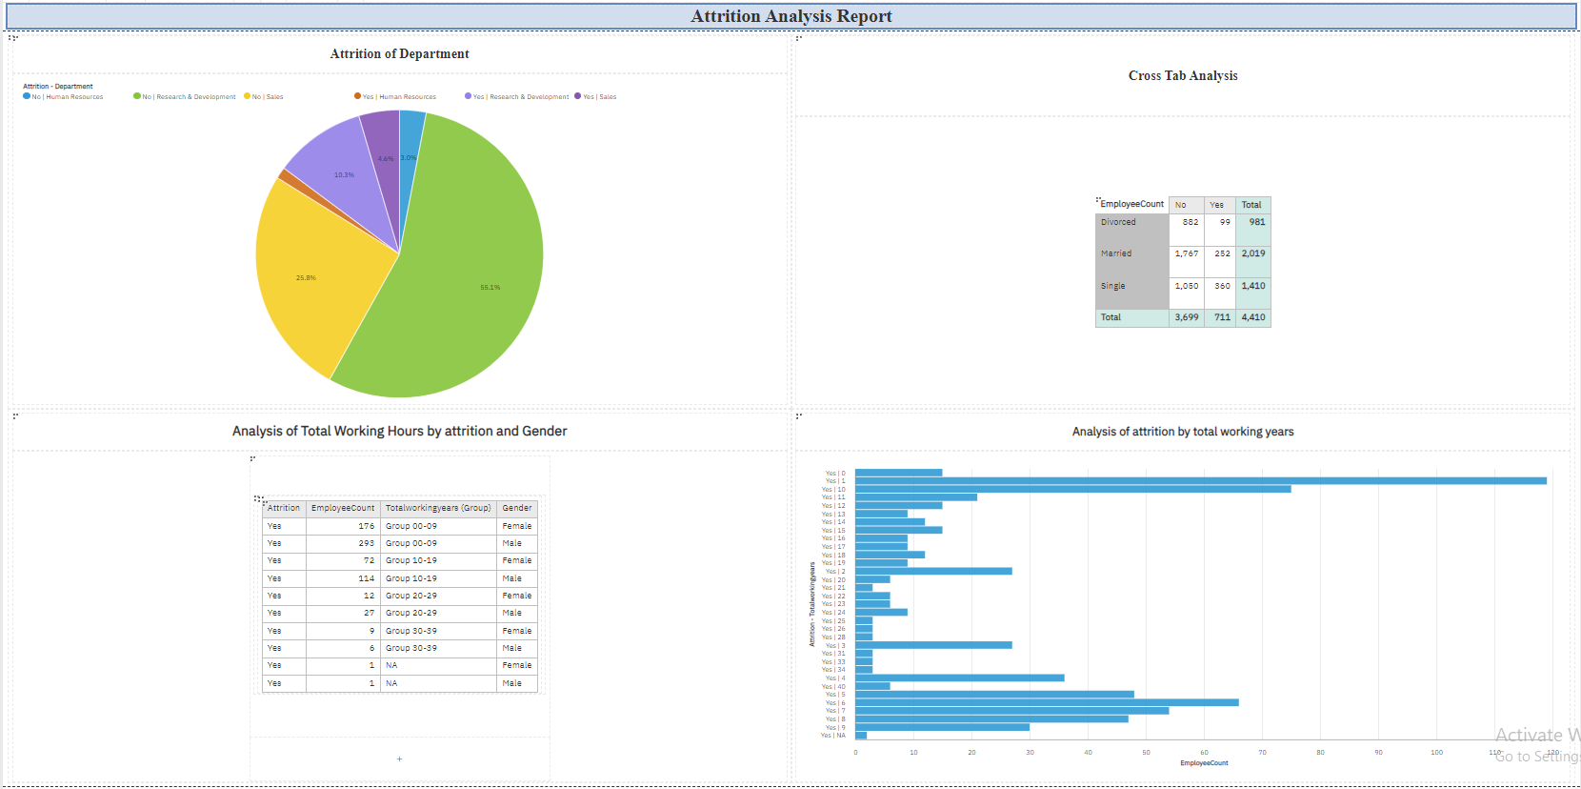

**Report Visualizations**



